- User Type - Establishment
- Add drop down menu as proof of document. This will be a mandatory field.
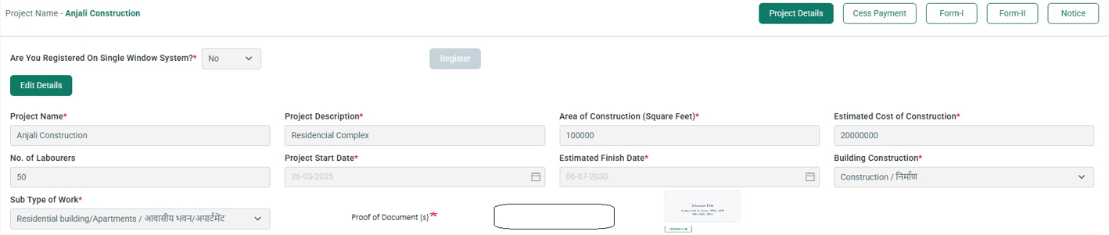
- The drop down menu will be as follows :

Work Order | LoI (Letter of Intent) | Bank Loan Statement
Approved Building Plan | Commencement Certificate | RERA Registration Certificate
Construction Contract Agreement | Sanction Letter | CA Certificate for Estimated Cost
Municipal NOC / Approval | Construction License | Affidavit of Self-Construction
Possession Certificate | Project DPR | GST Invoices

- Uploading document should be in JPEG, PNG & PDF format (max Size should be 5 mb)

- Rename as “ Building & Other Construction”
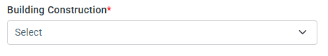

- Payer Details is getting auto populated

- Estimated cost of Construction should have value mentioned in (₹). At every place wherever cost is mentioned this change needs to be made.
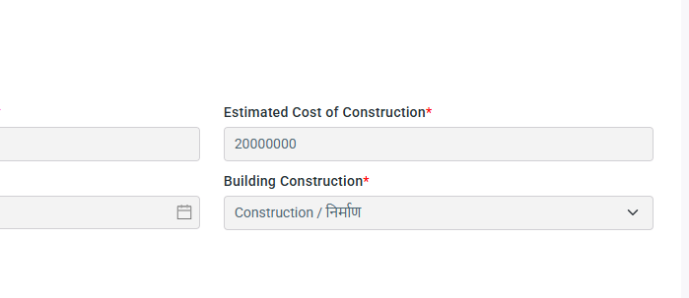

- File format should also be supported in PDF format also 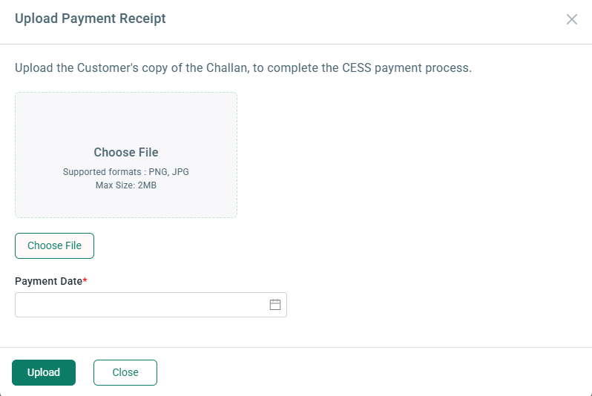

- Cess Calculation
The total cess amount should be 1% of total construction cost
In case where sub type of work is Residential Building or Commercial Building, the total cess amount should be calculated as per below stated logic:
Area of Construction (In Sq. Ft) | 10,000 | 10,000
Cost of construction (In Rs.) | 1,50,00,000 | 1,50,00,000
Cess calculation Basis | @1% of Cost of Construction | @17.22
Cess calculation Basis | @1% of Cost of Construction | per Sq. Ft
Cess Payable | 1,50,000 | 1,72,200
Whichever is higher | 1,72,200

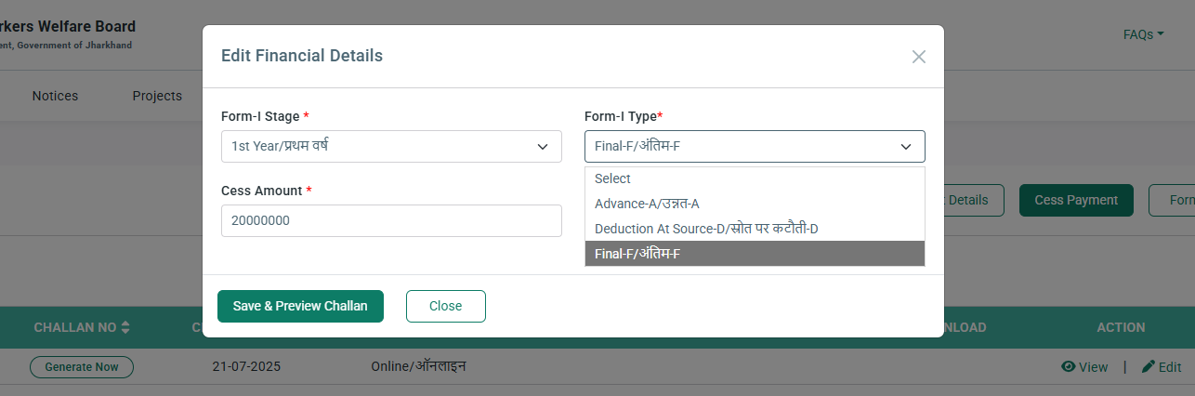
The Cess amount box should allow payment as per the above stated calculation and can be divided accordingly between Advance Payment and Final Payment.

- The session timeout should be for 30 minutes.
- Approved Challan format not updated in portal.
- Online Payment showcasing Error message.
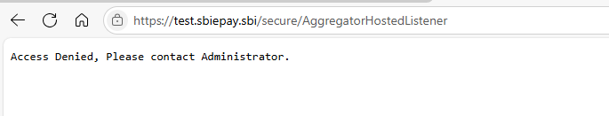

- There is no check for number of digits in IFSC code
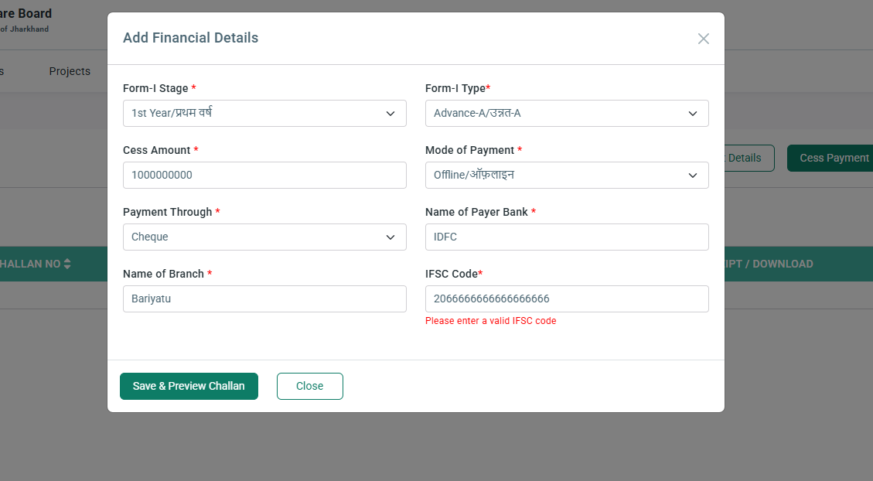

- NEFT and RTGS mode of payment is being showcased in Offline Payment
